|  |  |
| --- | --- |
|  |  |

|  |
| --- |
| **Activity 6.1.3 Static and Current Electricity** |

Introduction

When you gain an excess of electrons by walking across carpet, the electrons will look for an escape route. A doorknob or another person may be that escape route. As the electrons escape from your body, you feel the shock and hear a pop. This is static electricity. Lightning is also a form of static electricity. Have you ever seen a small spark jump from your finger to the doorknob? The spark is like lightning, and the pop that you sometimes hear is like thunder.

Electric charge can stand still or move. When it is standing still, it is called static electricity. When it is moving, it is called current electricity.

Equipment

* GTT Notebook
* Per group
* 2 – strips of 3 in. clear adhesive tape
* Styrofoam cup
* 3 – 4 pieces 1 in.2 scrap paper
* 1 lemon
* Multimeter
* 2 – leads with alligator clip ends
* Jumbo paperclip
* 2 ¼ in. section of 12 gauge copper wire (common household)
* Small (3mm) red LED per four groups (Light Emitting Diodes)

Procedure

In this activity you will work in teams of two to three to generate both static and current electricity.

Static Electricity is an accumulation of electric charge on an insulated body. In this activity you will create and observe static electricity with some common objects.

# Clear Adhesive Tape

1. Take 2 – 3 in. pieces of clear adhesive tape and fold back about ¼ in.
2. Stick the pieces of tape to a table or other surface. Leave the tab up as seen in the image below.

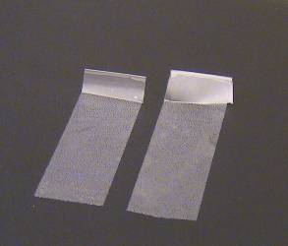

1. Carefully peel both pieces of tape off and hold them close to each other.
2. Did they repel or attract each other?

Repel

1. If you get them close to any other objects, do they repel or attract the other objects?

Attract

# Styrofoam Cup

1. Cut or tear paper to make 3 or 4 approximately 1 in. square pieces of paper and set them on your table or desk.
2. Can you pick up the scraps of paper with the Styrofoam cup?

No

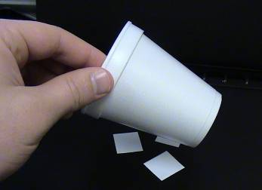

1. Explain what happens if you rub the cup against your hair and then attempt to pick up the scraps of paper.

I am able to pick up the paper scraps because of the static electricity on the cup has a different charge than the paper, and opposite charges attract.

Current Electricity is a controlled flow of electrons through a conductor such as wire.

# Citrus Battery

1. Push a jumbo paperclip and a piece of solid copper wire about halfway into a lemon as seen below.

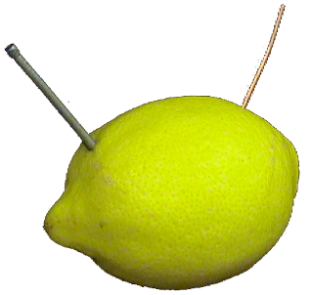

1. Connect the two leads from a multimeter to the paperclip and wire. Set the multimeter to measure voltage (V). Refer to Using a Multimeter.ppt to be sure that you are measuring voltage. Record the voltage. Be sure to label the value with a V for voltage.

0.751V

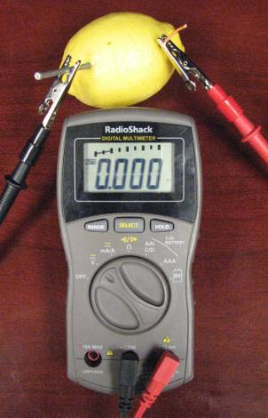

1. Switch the leads connected to the paperclip and copper wire and record the voltage.

-0.751V

1. Team up with another group and use alligator clip leads to connect two lemons together as shown below. Record the voltage and explain why there is a difference in voltage between one and two lemons.

1.787V

The voltage is different because there is more metal reacting with the acid/citrus in the lemons, creating more chemical potential energy.

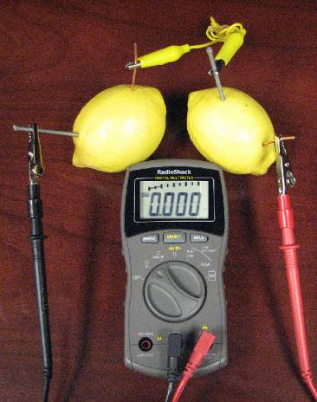

1. Continue to wire lemons among groups until you can light a small LED light. Record the number of lemons necessary and the voltage reading. **HINT:** LEDs will only allow electricity to flow in one direction. LEDs are polarized having an anode and cathode, so as you add lemons and try to light the LED, be sure to change the polarity if the LED doesn’t light right away.

4 lemons, 4.382V

**Conclusion**

1. What does the fact that the tape repelled tell you about the charge of each, if opposite charges attract and like charges repel?

That both pieces of tape had the same charge, positive or negative.

1. When you measured the voltage of the lemon and switched the leads, why do you think one value was negative and the other positive?

Because the flow was backwards in the circuit with a negative voltage.

1. Could you power a car, scooter, or bicycle with lemons? What would be the advantages and disadvantages of using such a device powered by lemons?

You could, and it would be clean energy, but it would take a massive amount of lemons power large electronics.